What is Dropout?

“Dropout” in machine learning refers to the process of randomly ignoring certain nodes in a layer during training.

In the figure below, the neural network on the left represents a typical neural network where all units are activated. On the right, the red units have been dropped out of the model — the values of their weights and biases are not considered during training.
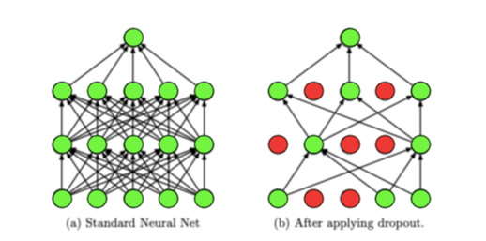
Adapted from Srivastava, Nitish, et al. ”Dropout: a simple way to prevent neural networks from
overfitting”, JMLR 2014. Dropout is used as a regularization technique — it prevents overfitting by ensuring that no units are codependent

How Does Dropout Work?

When we apply dropout to a neural network, we’re creating a “thinned” network with unique combinations of the units in the hidden layers being dropped randomly at different points in time during training. Each time the gradient of our model is updated, we generate a new thinned neural network with different units dropped based on a probability hyperparameter p. Training a network using dropout can thus be viewed as training loads of different thinned neural networks and merging them into one network that picks up the key properties of each thinned network.

"Thin" and "thick" networks are informal terms used to describe the number of neurons or units in the layers of a neural network.

- **Thin Network**: A thin network typically refers to a neural network architecture with a small number of neurons in its hidden layers. These networks are relatively shallow and have a limited capacity to learn complex patterns from the data. Thin networks are often used when the dataset is small or the problem is simple, as they require fewer computational resources and are less prone to overfitting.

- **Thick Network**: Conversely, a thick network refers to a neural network with a large number of neurons in its hidden layers. These networks are deeper and have a higher capacity to learn intricate features and patterns from the data. Thick networks are suitable for complex problems and large datasets, as they can capture more nuanced relationships and tend to yield better performance. However, they may require more computational resources for training and inference, and they are more susceptible to overfitting if not appropriately regularized.

In practice, the choice between thin and thick networks depends on various factors such as the complexity of the problem, the size of the dataset, computational resources, and the trade-off between model performance and generalization. It's essential to strike a balance between model complexity and simplicity to achieve the best results for a given task.

This process allows dropout to reduce the overfitting of models on training data.
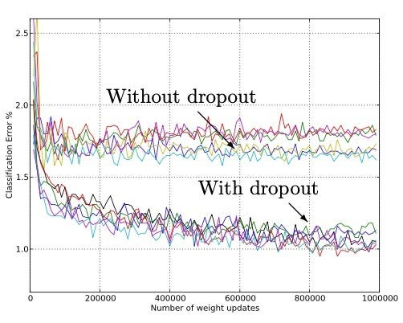
Srivastava, Nitish, et al. ”Dropout: a simple way to prevent neural networks from
overfitting”, JMLR 2014

This graph, taken from the paper “Dropout: A Simple Way to Prevent Neural Networks from Overfitting” by Srivastava et al., compares the change in classification error of models without dropout to the same models with dropout (keeping all other hyperparameters constant). All the models have been trained on the MNIST dataset.

It is observed that the models with dropout had a lower classification error than the same models without dropout at any given point in time. A similar trend was observed when the models were used to train other datasets in vision, as well as speech recognition and text analysis.

The lower error is because dropout helps prevent overfitting on the training data by reducing the reliance of each unit in the hidden layer on other units in the hidden layers.

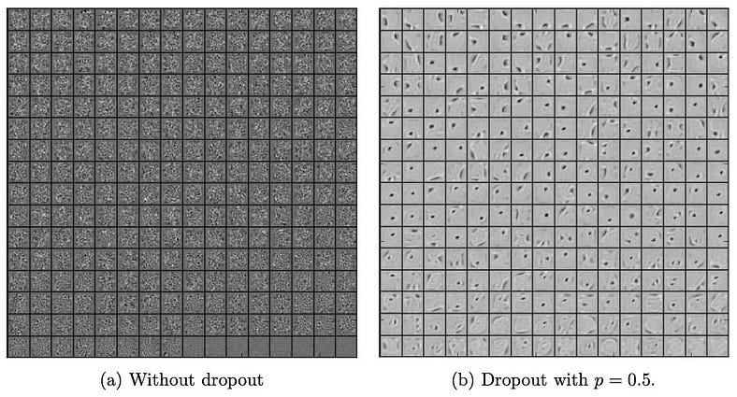

Srivastava, Nitish, et al. ”Dropout: a simple way to prevent neural networks from
overfitting”, JMLR 2014

These diagrams taken from the same paper show the features learned by an autoencoder on MNIST with one layer of 256 units without dropout (a) and the features learned by an identical autoencoder that used a dropout of p = 0.5 (b). It can be observed in figure a that the units don’t seem to pick up on any meaningful feature, whereas in figure b, the units seem to have picked up on distinct edges and spots in the data provided to them.
This indicates that dropout helps break co-adaptations among units, and each unit can act more independently when dropout regularization is used. In other words, without dropout, the network would never be able to catch a unit A compensating for another unit B’s flaws. With dropout, at some point unit A would be ignored and the training accuracy would decrease as a result, exposing the inaccuracy of unit B.

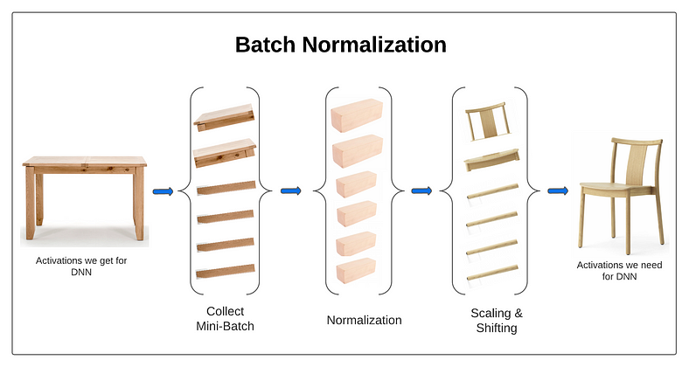
Batch normalization operation

Batch normalization is a technique used in deep learning where a special layer is added before or after an activation layer. This layer performs operations to standardize and normalize the input coming from the previous layer. We will discuss the operation in above picture in “How it works” section, now let’s consider this example given below:

Imagine you have a group of runners getting ready for a race. Each runner has a unique pace and stamina. Some are naturally faster, while others may tire more quickly.
Batch normalization is like having a coach who helps standardize and optimize the performance of each runner. The coach measures the fitness levels of all the runners and adjusts their pace and stamina to bring them to a similar level.

During training, the coach observes how each runner is doing and normalizes their speed and endurance based on the entire group’s performance. If a runner is too fast, the coach might slow them down a bit. If a runner is struggling, the coach might boost their stamina. This way, all the runners stay balanced and have an equal chance to excel.

How does it works?

Step 1: Collect Mini-Batch

Imagine you have a mini-batch of data consisting of several samples. Each sample has multiple attributes or features. Let’s say you have a mini-batch with a size of 4 samples, and each sample has 3 attributes. This mini-batch can be represented as a 4x3 matrix.

In this dummy example, we have a complete table, which we divide into 6 mini-batches passes through single neuron (or feature).

Step 2: Normalization
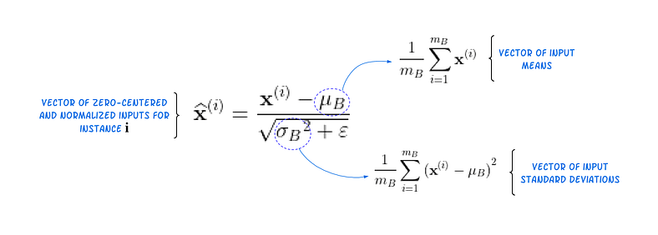
For each feature dimension (column), calculate the mean and variance within the mini-batch. Then normalize the activations for each feature dimension based on the mean and variance calculated in the previous step.

This normalization is done by subtracting the mean from each value in the corresponding column and dividing it by the square root of the variance. The result is a normalized activation matrix, where the values have zero mean and unit variance along each feature dimension.

In our dummy example, batch normalization converts pieces of a table (or mini-batches of table) into standardized wooden blocks. This process ensures that all the blocks have a mean = 0 and std = 1, making them appear similar and consistently scaled.

Step 3: Scaling and Shifting
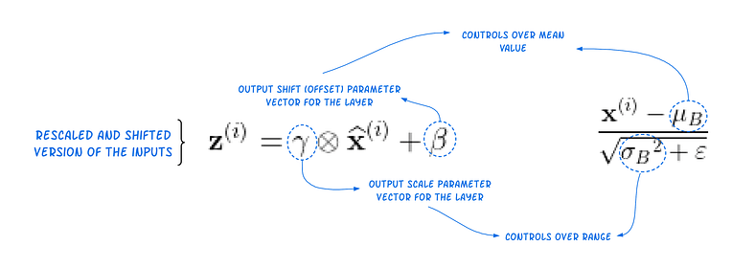
Apply scaling and shifting operations to the normalized activations. This step introduces two additional parameters, scale and shift, which are learnable parameters of batch normalization.
Scaling involves multiplying each normalized value by a scale parameter, allowing the network to learn the appropriate range for the activations. Shifting involves adding a shift parameter to each normalized value, enabling the network to learn the optimal mean value for the activations.

In our dummy example, the scale and shift parameters learn that the activations should be in the shape of a chair. Since we already have the wooden blocks (normalized activations), it becomes easier to transform them into the required mean and range for each block based on their previous behavior.

Throughout training, Batch Normalization exerts control over the mean and range of mini-batches to ensure smooth gradient flow and address the covariate shift.

Sure, here's the information in plaintext format:

Standardization:
- Rescales features to have a mean of 0 and a standard deviation of 1.
- Formula: x_standardized = (x - μ) / σ, where x is the original feature value, μ is the mean, and σ is the standard deviation.
- Less affected by outliers compared to normalization.

Normalization:
- Rescales features to a range between 0 and 1.
- Formula: x_normalized = (x - min(x)) / (max(x) - min(x)), where x is the original feature value.
- Sensitive to outliers as it uses the minimum and maximum values.
- Suitable for algorithms requiring input data on a similar scale.

standardization transforms the data to have a mean of 0 and a standard deviation of 1, making it suitable for algorithms that assume Gaussian distribution in the input variables, while normalization scales the data to a fixed range (usually between 0 and 1), making it suitable for algorithms that require input data to be on a similar scale.

This excerpt describes the process of applying scaling and shifting operations as part of batch normalization in a neural network.

1. **Scaling**:
- Scaling involves multiplying each normalized activation value by a learnable scale parameter.
- The purpose of scaling is to allow the neural network to learn the appropriate range for the activations. By adjusting the scale parameter, the network can control the magnitude of the normalized activations.

2. **Shifting**:
- Shifting involves adding a learnable shift parameter to each normalized activation value.
- The purpose of shifting is to enable the network to learn the optimal mean value for the activations. By adjusting the shift parameter, the network can control the center or bias of the normalized activations.

scaling and shifting operations, along with normalization, help stabilize and improve the training of neural networks by allowing them to learn optimal ranges and mean values for the activations. These parameters are learned during the training process along with the other parameters of the network.

Covariate shift, sometimes referred to as "covariance shift," is a phenomenon that occurs when the input distribution of a dataset changes between training and testing phases in machine learning. In other words, it describes a situation where the statistical properties (such as mean and variance) of the input features change across different datasets or different time periods.

When covariate shift happens, a model trained on one dataset may not perform well on another dataset, even if both datasets come from the same underlying distribution. This is because the model has learned patterns specific to the training dataset that do not generalize well to the testing dataset due to the shift in distribution.

To address covariate shift, various techniques can be employed during the training process, such as:

1. **Feature scaling and normalization**: Ensuring that the input features are on similar scales across datasets can help mitigate the effects of covariate shift.

2. **Domain adaptation**: Techniques that aim to adapt the model from the source domain (training data) to the target domain (testing data) by aligning their feature distributions.

3. **Importance weighting**: Assigning different weights to examples during training to compensate for the differences in distribution between the training and testing datasets.

By addressing covariate shift, models can achieve better generalization performance and be more robust to changes in the input distribution.

Batch normalization (BN) layers are typically placed before the activation function in a neural network architecture. Whether they should be placed before or after dense (fully connected) layers depends on the specific architecture and the design choices made during model development.

However, the most common practice is to place the batch normalization layer before the activation function, which is typically right after the output of the linear transformation (e.g., the dense layer). This allows the batch normalization layer to normalize the input to the activation function, which can help stabilize and speed up the training process.

Here's the typical order of operations in a neural network layer:
- Linear transformation (e.g., dense layer): z = Wx + b
- Batch normalization: Normalize the output z using batch statistics.
- Activation function: Apply the activation function (e.g., ReLU, sigmoid, tanh) to the normalized output.
- Dropout Layer Add

Placing the batch normalization layer before the activation function ensures that the input to the activation function is normalized, which helps to keep the activations within a certain range and prevents them from drifting too far from the mean, especially during deep network training.

So, in summary, it's generally recommended to place batch normalization layers before dense (fully connected) layers and before the activation function.

Optimizers in Deep Learning

What is an optimizer?

Optimizers are algorithms or methods used to minimize an error function (loss function) or to maximize the efficiency of production. Optimizers are mathematical functions which are dependent on model’s learnable parameters i.e. Weights & Biases. Optimizers help to know how to change weights and learning rate of neural network to reduce the losses.

Types of optimizers

Let’s learn about different types of optimizers and how they exactly work to minimize the loss function.

Gradient Descent

Gradient descent is an optimization algorithm based on a convex function and tweaks its parameters iteratively to minimize a given function to its local minimum. Gradient Descent iteratively reduces a loss function by moving in the direction opposite to that of steepest ascent. It is dependent on the derivatives of the loss function for finding minima. uses the data of the entire training set to calculate the gradient of the cost function to the parameters which requires large amount of memory and slows down the process.
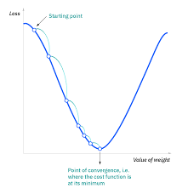
Gradient Descent
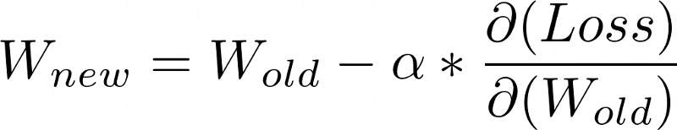
Advantages of Gradient Descent
Easy to understand
Easy to implement

Disadvantages of Gradient Descent
Because this method calculates the gradient for the entire data set in one update, the calculation is very slow.
It requires large memory and it is computationally expensive.

Learning Rate
How big/small the steps are gradient descent takes into the direction of the local minimum are determined by the learning rate, which figures out how fast or slow we will move towards the optimal weights.
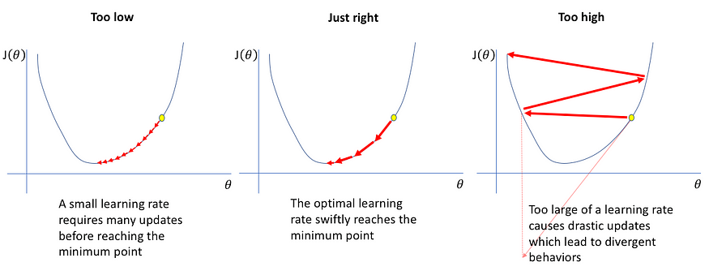
Learning Rate

Stochastic Gradient Descent
It is a variant of Gradient Descent. It updates the model parameters one by one. If the model has 10K dataset SGD will update the model parameters 10k times.
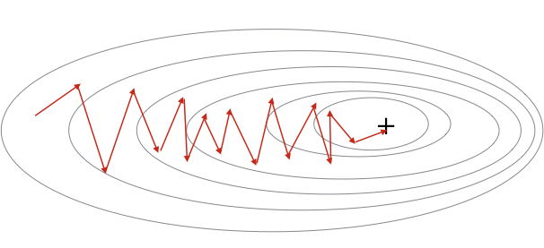
Stochastic Gradient Descent

Advantages of Stochastic Gradient Descent
Frequent updates of model parameter
Requires less Memory.
Allows the use of large data sets as it has to update only one example at a time.

Disadvantages of Stochastic Gradient Descent
The frequent can also result in noisy gradients which may cause the error to increase instead of decreasing it.
High Variance.
Frequent updates are computationally expensive.

Mini-Batch Gradient Descent
It is a combination of the concepts of SGD and batch gradient descent. It simply splits the training dataset into small batches and performs an update for each of those batches. This creates a balance between the robustness of stochastic gradient descent and the efficiency of batch gradient descent. it can reduce the variance when the parameters are updated, and the convergence is more stable. It splits the data set in batches in between 50 to 256 examples, chosen at random.
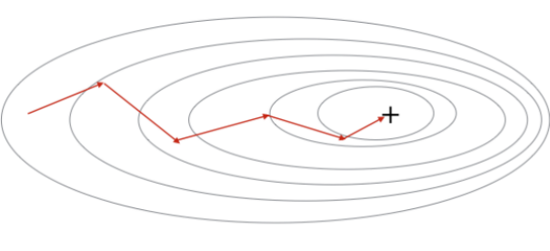
Mini Batch Gradient Descent

Advantages of Mini Batch Gradient Descent:
It leads to more stable convergence.
more efficient gradient calculations.
Requires less amount of memory.

Disadvantages of Mini Batch Gradient Descent

Mini-batch gradient descent does not guarantee good convergence,
If the learning rate is too small, the convergence rate will be slow. If it is too large, the loss function will oscillate or even deviate at the minimum value.

SGD with Momentum

SGD with Momentum is a stochastic optimization method that adds a momentum term to regular stochastic gradient descent. Momentum simulates the inertia of an object when it is moving, that is, the direction of the previous update is retained to a certain extent during the update, while the current update gradient is used to fine-tune the final update direction. In this way, you can increase the stability to a certain extent, so that you can learn faster, and also have the ability to get rid of local optimization.
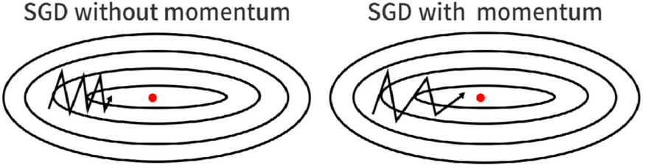
SGD with Momentum
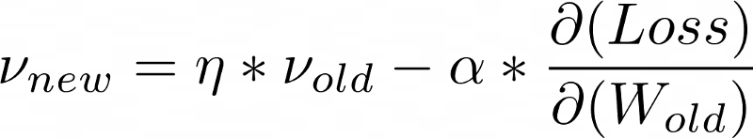
Momentum Formula

Advantages of SGD with momentum
Momentum helps to reduce the noise.
Exponential Weighted Average is used to smoothen the curve.

Disadvantage of SGD with momentum
Extra hyperparameter is added.

AdaGrad(Adaptive Gradient Descent)
In all the algorithms that we discussed previously the learning rate remains constant. The intuition behind AdaGrad is can we use different Learning Rates for each and every neuron for each and every hidden layer based on different iterations.
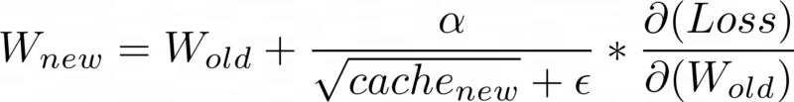

Advantages of AdaGrad
Learning Rate changes adaptively with iterations.
It is able to train sparse data as well.

Disadvantage of AdaGrad
If the neural network is deep the learning rate becomes very small number which will cause dead neuron problem.

RMS-Prop (Root Mean Square Propagation)
RMS-Prop is a special version of Adagrad in which the learning rate is an exponential average of the gradients instead of the cumulative sum of squared gradients. RMS-Prop basically combines momentum with AdaGrad.
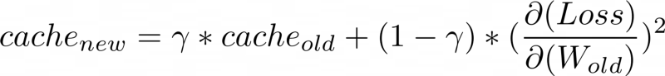
Advantages of RMS-Prop
In RMS-Prop learning rate gets adjusted automatically and it chooses a different learning rate for each parameter.

Disadvantages of RMS-Prop
Slow Learning

AdaDelta
Adadelta is an extension of Adagrad and it also tries to reduce Adagrad’s aggressive, monotonically reducing the learning rate and remove decaying learning rate problem. In Adadelta we do not need to set the default learning rate as we take the ratio of the running average of the previous time steps to the current gradient.

Advantages of Adadelta
The main advantage of AdaDelta is that we do not need to set a default learning rate.

Disadvantages of Adadelta
Computationally expensive

Adam(Adaptive Moment Estimation)
Adam optimizer is one of the most popular and famous gradient descent optimization algorithms. It is a method that computes adaptive learning rates for each parameter. It stores both the decaying average of the past gradients , similar to momentum and also the decaying average of the past squared gradients , similar to RMS-Prop and Adadelta. Thus, it combines the advantages of both the methods.
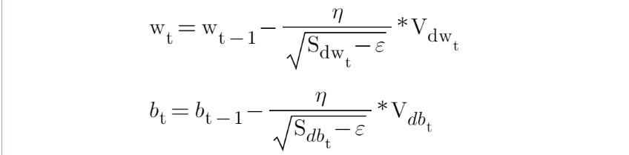
Advantages of Adam

Easy to implement
Computationally efficient.
Little memory requirements.

Comparison
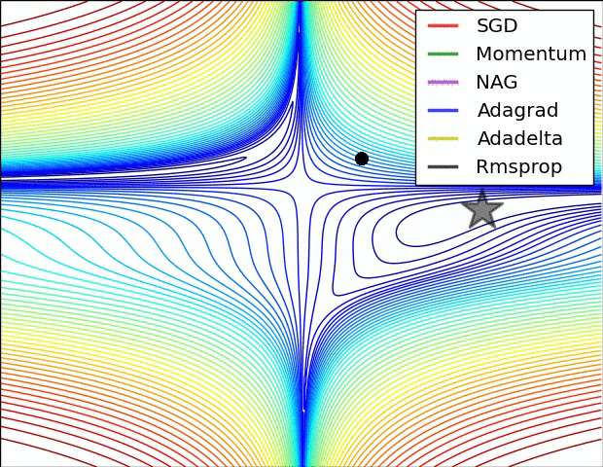
Optimizers Comparison
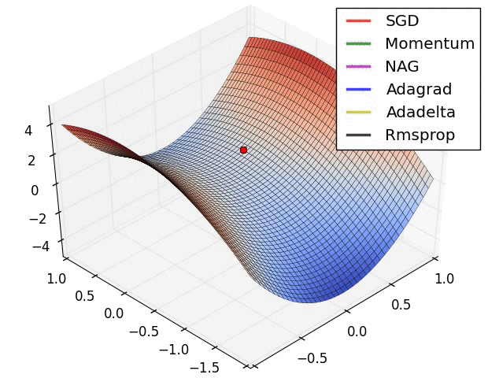

Optimization on saddle point
How to choose optimizers?
If the data is sparse, use the self-applicable methods, namely Adagrad, Adadelta, RMSprop, Adam.
RMSprop, Adadelta, Adam have similar effects in many cases.
Adam just added bias-correction and momentum on the basis of RMSprop,
As the gradient becomes sparse, Adam will perform better than RMSprop.

The loss functions for classification and regression tasks:

### Losses in Classification:

1. **Binary Cross-Entropy Loss (Log Loss)**:
- Suitable for binary classification tasks.
- Measures the difference between probability distributions of two classes.
- Formula:
Binary Cross-Entropy Loss = -1/N * Σ [y_i * log(p_i) + (1 - y_i) * log(1 - p_i)]
- N is the number of samples, y_i is the true label (0 or 1), and p_i is the predicted probability of class 1.

2. **Categorical Cross-Entropy Loss**:
- Suitable for multi-class classification tasks.
- Measures the difference between the true distribution and the predicted distribution of classes.
- Formula:
Categorical Cross-Entropy Loss = -1/N * Σ Σ y_ij * log(p_ij)
- N is the number of samples, C is the number of classes, y_ij is the indicator function (1 if sample i belongs to class j, 0 otherwise), and p_ij is the predicted probability of sample i belonging to class j.

3. **Sparse Categorical Cross-Entropy Loss**:
- Similar to Categorical Cross-Entropy Loss but expects integer targets instead of one-hot encoded targets.
- It's more memory efficient when the number of classes is large.
- It internally converts integer targets to one-hot encoded targets.

### Losses in Regression:

1. **Mean Squared Error (MSE)**:
- Commonly used for regression tasks.
- Measures the average squared difference between the predicted values and the actual values.
- Formula:
MSE = 1/N * Σ (y_i - ŷ_i)^2
- N is the number of samples, y_i is the true value, and ŷ_i is the predicted value.

2. **Mean Absolute Error (MAE)**:
- Also known as L1 Loss.
- Measures the average absolute difference between the predicted values and the actual values.
- Formula:
MAE = 1/N * Σ |y_i - ŷ_i|

3. **Huber Loss**:
- Combines the advantages of MSE and MAE.
- Less sensitive to outliers compared to MSE.
- It uses a hyperparameter (δ) to determine the point where it becomes quadratic instead of linear.
- Formula:
L_δ = { (1/2)(y - ŷ)^2 if |y - ŷ| ≤ δ, δ(|y - ŷ| - (1/2)δ) otherwise }

These are just a few examples of loss functions used in classification and regression tasks. The choice of loss function depends on the specific problem and the properties of the data.

